**Enrollment No:** 2202031000165

**Name:** Lisa Zalavadiya

**Semester:** 4th

**Branch:** B. Tech (IT)

**Division:** 4IT2 M2

**Subject**: Web Technology with UI/UX (1010043228)

**UIUX**

**Step – 1:**

* Make GitHub account
* Open GitHub
* Click “New” Button

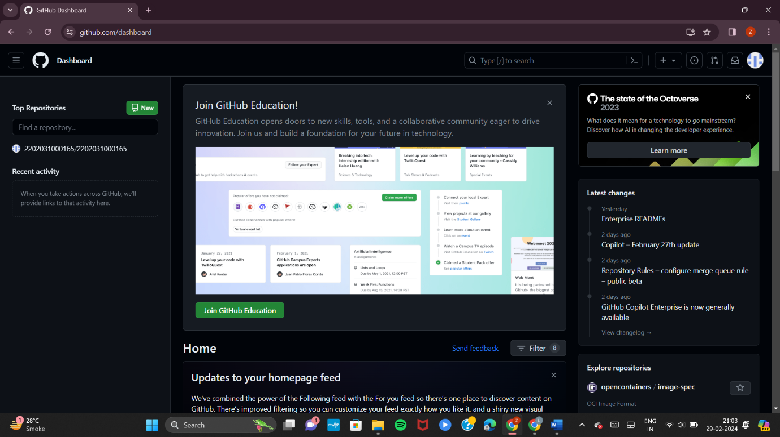

**Step – 2:**

* Enter Repository name (enrollment number)

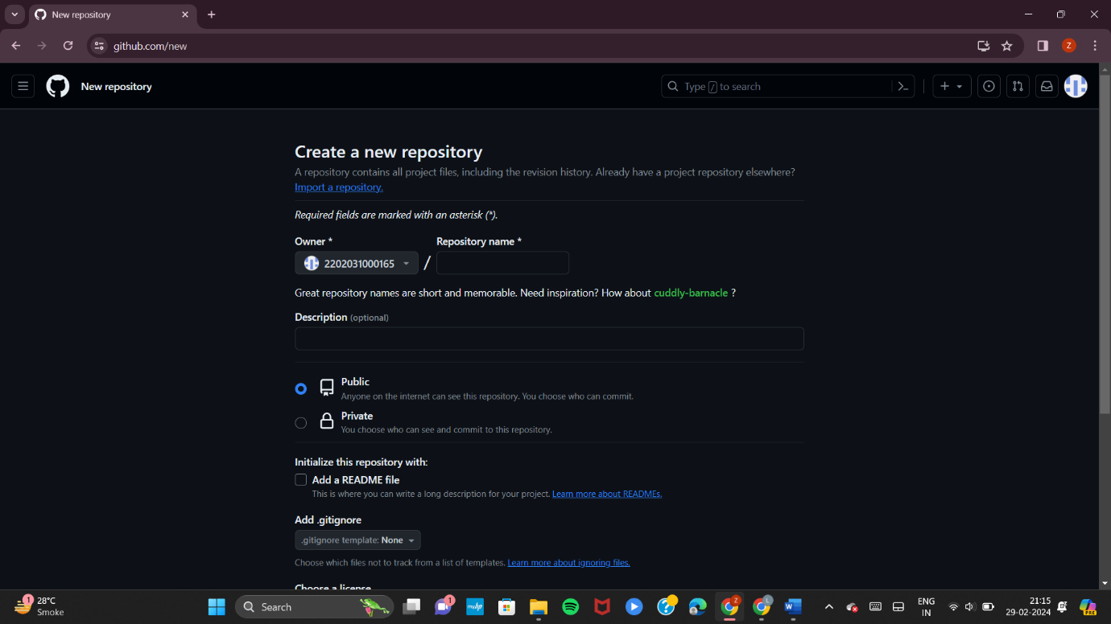

**Step – 3:**

* After entering Repository name
* Also, check “Add a README file”
* Click “Create Repository” Button

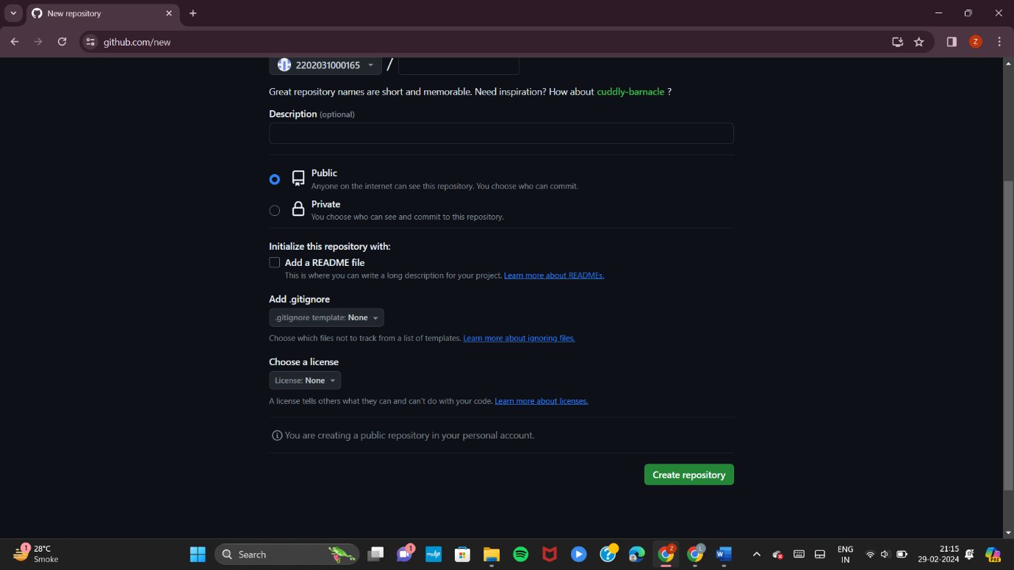

**Step – 4:**

* Now, your repository created
* Now, click on “Code” button

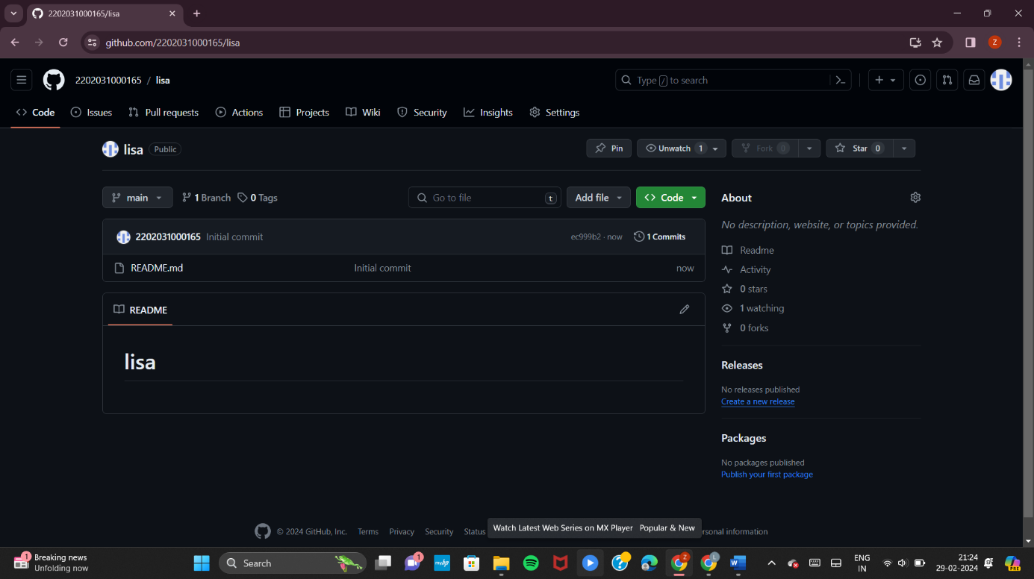

**Step – 5:**

* Copy the HTTPS URL

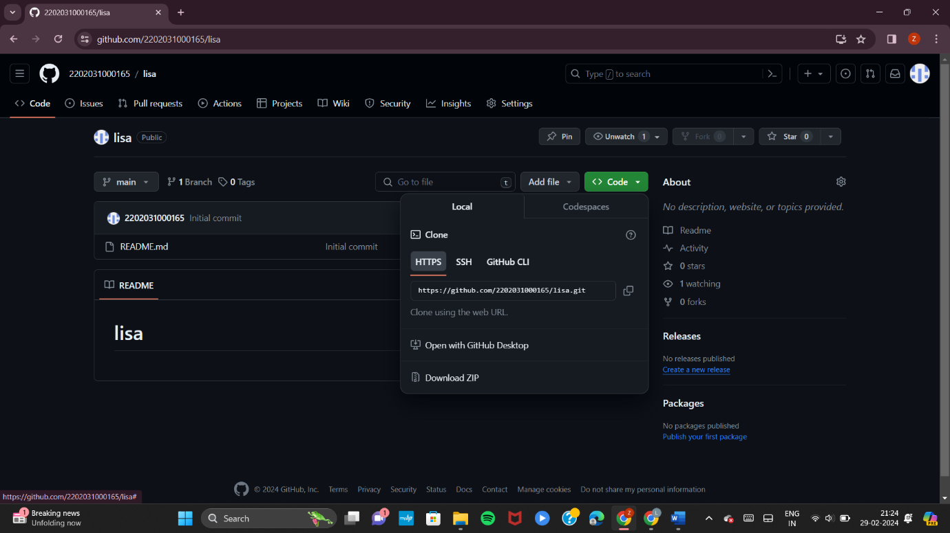

**Step – 6:**

* Now, clone the git repo using this URL
* Command: git clone <URL>

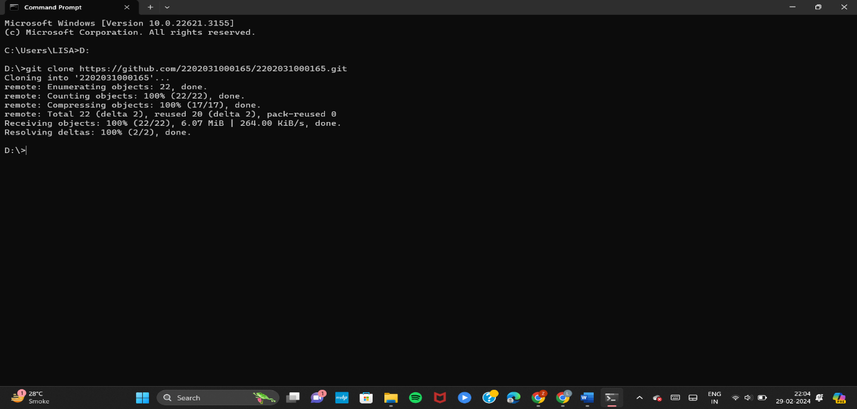

**Step – 7:**

* After cloning the repo, folder was created with name of our repo name

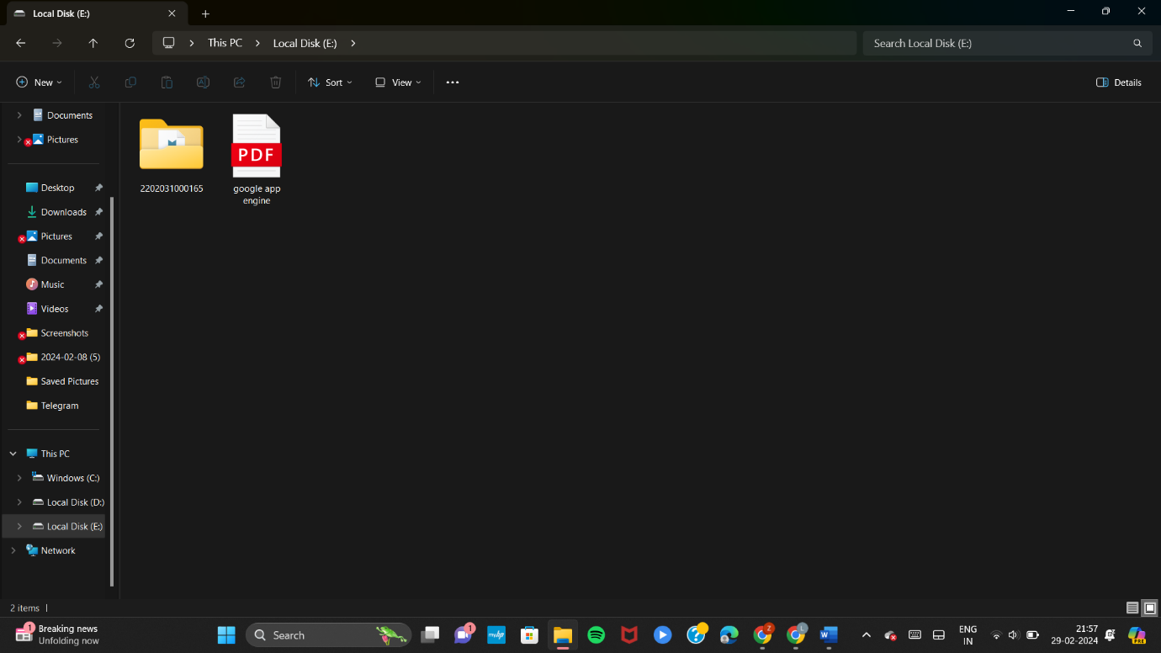

**Step – 8:**

* Now, in this folder create two folders named “Assignment_1” and “Assignment_2”.

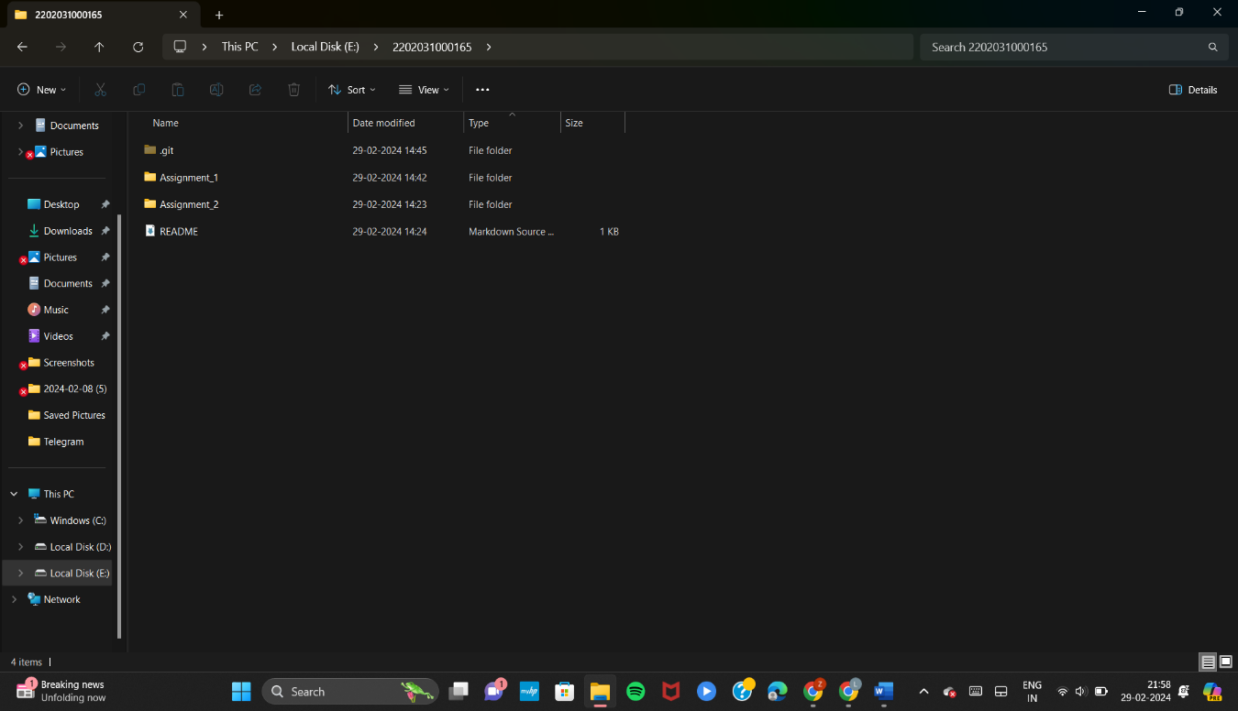

**Step – 9:**

* In Assignment_1 folder add your assignment file

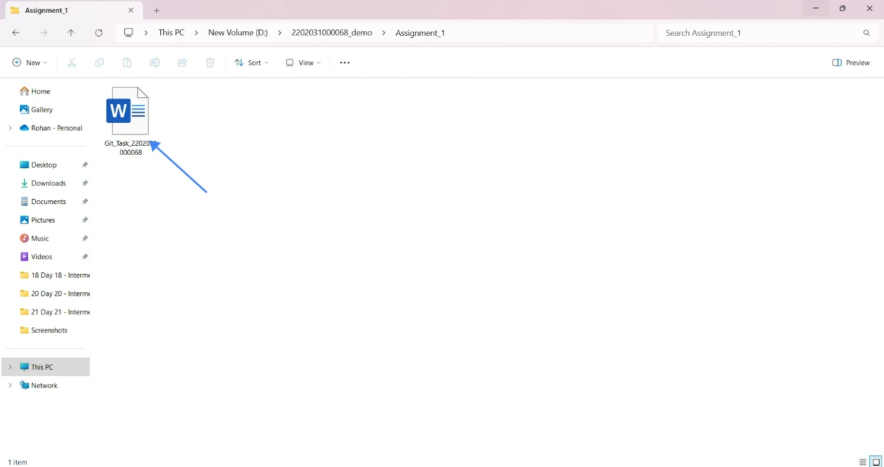

**Step – 10:**

* We can see the changes in our git repo using the command
* Command: git status

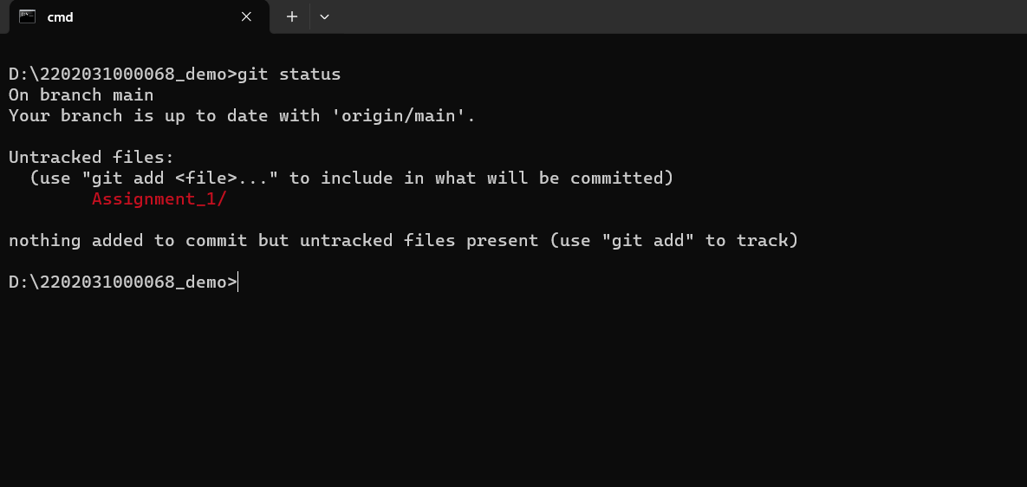

**Step – 11:**

* Now, using the below command add all changes in repo
* Command: git add .
* After we can see the save changes in our git folder

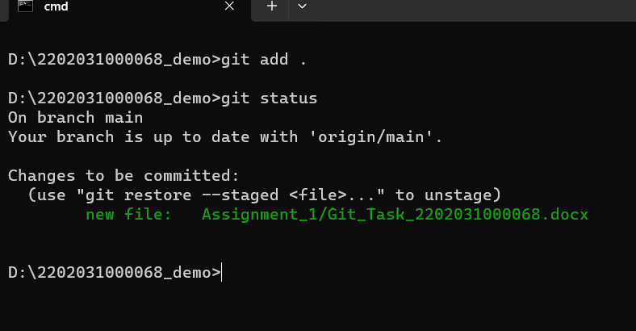

**Step – 12:**

* Now, using the command we can commit the changes
* Command: git commit -m “<commit message>”

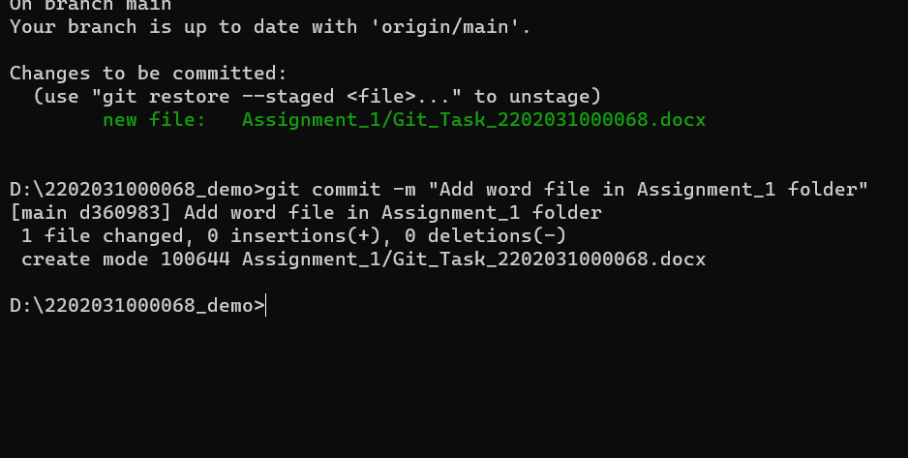

**Step – 13:**

* Now, using the below command we push our changes in remote branch
* Command: git puh origin main

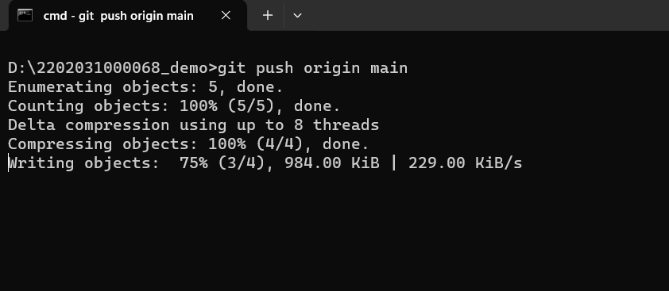

**Step – 14:**

* Now, refresh your git repo
* We can see changes in GitHub

